
Awarded to:
GREENPOWER EDUCATION TRUST

This organisation has therefore pledged to:

- Engage in an ongoing process to sustain high quality learning outside the classroom

- Meet all of the Learning Outside the Classroom Quality Badge indicators

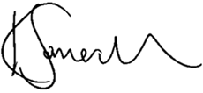
Kim Somerville
Chief Executive, Council for Learning Outside the Classroom

R2QB102838
Certificate no.

10/04/2019
10/04/2021
Date issued: Expiry date:

www.lotcqualitybadge.org.uk

The Council for Learning Outside the Classroom is registered in the United Kingdom no. 6778701.

